# MERN Troubleshooting

* [MERN Cheatsheet](https://docs.google.com/document/d/1cYuL3TRUZLErwkA3bBhvIRTrSdMlYzufkMx5dMtCg0k/edit)

## Webpack

### Installed globally

Delete the webpack folders inside of **C:\users\username\node_modules**

## Windows

### Space in user name

configure **npm** to use Windows Short Names

alternatively rename their username

## Frontend

#### create-react-app

##### Incorrect jest version

* Create a file named **.env** file and add **SKIP_PREFLIGHT_CHECK=true** in the file

### Extra Renders

* <React.StrictMode> in **index.js**
  + causes extra renders only in development when using hooks
  + intentional behavior to help catch unintended side effects, can be removed to avoid extra re-renders but it is there to help catch difficult to find bugs.

### Can’t perform a React state update on an unmounted component

* This means a set state is happening on a component that is no longer being displayed because you routed away from it while a request was still pending which when finished triggers a state update.
* If you are trying to **navigate** after an API call, make sure to only call the **navigate** function inside of the **.then**  or **.catch**, because API calls are async so putting the navigate under them is not a guarantee that it will happen after.
* Also make sure in the dependency array of your **useEffect** (the 2nd argument of useEffect) you DO NOT have a state var there that is the SAME state var that is being that state is set the effect will trigger again but the **useEffect** will set it, triggering it again and again..

### A component is changing an uncontrolled input

* Make sure the **<input>** has an onChange and the **<input>** has a **value={yourStateVar}**
* Also make sure you do not set the value of an **<input>** to undefined. Don’t default the state var to undefined and when you update the state var that is connected to the value of the **<input>**, make sure you don’t set it to undefined later which can happen if you misspell a key name or your db data comes back with missing data for a key, e.g., on an optional field that was given no value when created.

### Error: No valid exports main found for '\node_modules\colorette'

* Full error: create-react-app starting error - Error: No valid exports main found for '\node_modules\colorette'
* Uninstall node and then [install](https://nodejs.org/en/download/current/) version 14.5+
* If you are having problems uninstalling or switching node versions on MAC, you can download nvm. [How to switch node versions with NVM.](https://reactgo.com/nvm-uninstall-active-node-version/)

### API Calls

* [Access-Control-Allow-Origin](https://create-react-app.dev/docs/proxying-api-requests-in-development/) issues.

## Backend

### Installing MongoDB

#### Windows

* When installing / reinstalling, make sure to check the “run as windows service”
* If the server keeps stopping soon after it’s started, you may need to manually allow it through the firewall.

#### Mac

##### [Install on M1](https://www.youtube.com/watch?v=f3iFaiBGVYw)

##### Permission Errors

* [Download](https://www.mongodb.com/try/download/community) the installer from the right side of the page and then use the downloaded file to install

### Deployment

* **mv: cannot stat 'build': No such file or directory**
  + you forgot the deployment step that has you delete the **.gitignore** in the **client** folder, search **gitignore** on the deployment steps page

## npm

### **npx create-react-app** not working

* Before you re-test anything, re-open your terminal
* Make sure you have it installed globally **npm i -g create-react-app** then try **npx create-react-app app-name** again
* If it still doesn’t work, before spending a long time searching for answers, it may be easiest to simply uninstall node, restart computer, reinstall node, reinstall create-react-app then try again.

#### Space in Windows username operation not permitted, mkdir

* If you have a space in your windows username, this could be causing the problem

1. Get your current path: **npm config get prefix**
2. Set the npm config with **your path from step 1** but replace spaces with **~1** as seen in this example: npm config set cache "C:\Users\Firstname~1\AppData\Roaming\npm-cache" --global
   * This is an example where Firstname is a first name and the ~1 replaces where the space and lastname would be, you need to use your own path
3. 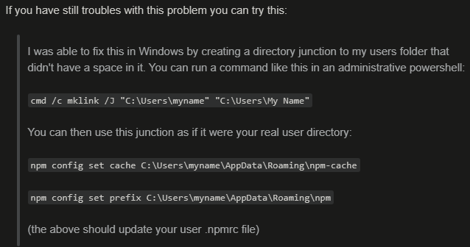

### ERESOLVE

* Unable to resolve dependency tree
  + npm install PACKAGE-NAME --save --legacy-peer-deps

## Nodemon

### MODULE_NOT_FOUND

* Error: Cannot find module **‘packageName’**
  + You probably forgot to install the package or misspelled it.
* **some\path\index.js'** 
  + **nodemon server.js** this probably means you have your terminal open to a folder that your **server.js** is not in. Make sure to cd to the folder that has your **server.js** then try again.

### EADDRINUSE: address already in use

* You have another terminal already running this same port, stop the other terminal.

### Windows

#### Running scripts is disabled



* Don’t use powershell, change Vscode to use cmd
  + Ctrl + shift + p then type: shell
    - Select cmd
    - If cmd is not available
    - Ctrl + shift + p then type open settings (JSON)
    - "Terminal.integrated.shell.windows": "C:\\Windows\\System32\\cmd.exe"
* To keep using powershell, run this command in powershell: Set-ExecutionPolicy unrestricted

## Delete all **node_models** folders from terminal

* **find . -name 'node_modules' -type d -prune -exec rm -rf '{}' +**